Purpose
Offering tips for easier printing on the Idaho Division of Occupational and Professional Licenses (DOPL).

Printing
- Dates, times, and URLs
  - For Chrome, Firefox, and Edge, the setting to show these when printing are available in the print settings of each. These settings can be accessed by selecting Ctrl+P then choosing More Settings and selecting the Headers & Footers. Snips for each can be found at the links below:
    - Chrome
    - Firefox
    - Edge

- Scale
  - When printing in DOPL, you might see that the way it prints out is frustrating to read at best. Allow yourself to be kind to future you when audits or general questions come up and use the Scale function in the same ‘More Settings’ section when printing. A scale of 68 seems to be a sweet spot where it allows the text to still be large enough to read without keeping that popup to an unreasonable size.
Chrome
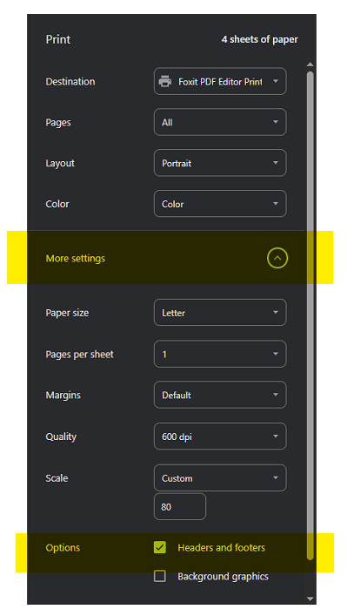

Firefox
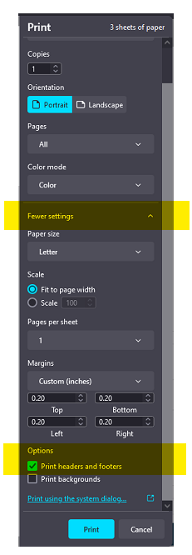
Edge
